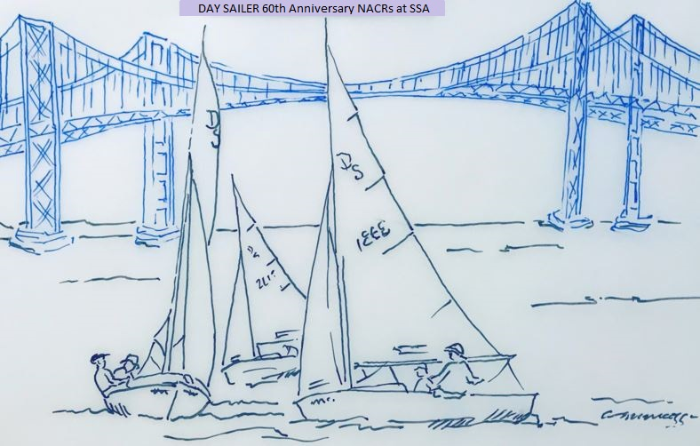
NOTICE OF RACE
Day Sailer 60th Anniversary North American Championship Regatta
Annapolis, Maryland
August 23 to 28, 2021

1. HOST AND ORGANIZING AUTHORITY
Day Sailer Association members of Fleet 1, Annapolis, MD and Severn Sailing Association (SSA), 311 First Street, Annapolis, MD 21403.
2. RULES
This regatta will be governed by the 2021-2024 Racing Rules of Sailing, the prescriptions of U.S. Sailing, the rules of the Day Sailer Association, and by the Sailing Instructions.
3. ELIGIBILITY
Current Day Sailer members, as defined by the Day Sailer Association, are eligible. All competing boats will be measured. Boats with a current measurement certificate will be honored for everything excluding boat weight and measurements of new sails.
4. ENTRY
Competitors may enter by filling out and returning a completed entry form and paying applicable fees. Early registration fee is $400.00. All registrations postmarked before July 19th will be “early”. Late registration fee is $450.00. Late registrations will be accepted from July 20th through August 25th 12 Noon. Registration fee includes T-shirts and hats for skipper and crew, and two tickets for the welcome dinner, Annual General Meeting (AGM) dinner (buffet), and the closing awards banquet. Additional T-shirts, hats and dinners are available for extra fees.
Send registrations to Thomas Shaw, 27 Murray Avenue Annapolis, MD 21401. Questions regarding registration should be directed via email at thomas_shaw@verizon.net.
Or register on-line at: https://club.severnsailing.org/event/584
5. VENUE & SAILING AREA
All races will originate at Severn Sailing Association in historic Annapolis, Maryland. Situated across Spa Creek from the US Naval Academy, and with a view of Annapolis Harbor, SSA has a half-century tradition of quality one-design racing, and regularly hosts major regional, national and international championship events on the Chesapeake Bay, a premier worldwide sailing venue. Racing will be conducted on the Chesapeake Bay, NOAA Chart #12270, within 5 miles of SSA.
6. SCHEDULE
Date and Day | Time |  | Activity
August 23, Monday | Noon to 5:00 pm |  | NACR and Jr NACR Registration, Early Measurement
August 24, Tuesday | 9:00 am to 4:00 pm  11:30 am  1:30 pm | NACR Registration, Measurement  Jr NACR Skippers Meeting  1st Warning Signal Jr NACRs First Race; other races to follow
August 25, Wednesday | 9:00 am to 12 noon  11:00 am  3:00 pm  6:00 pm |  | NACR Registration, Measurement  1st Warning Signal Jr NACRs  No Jr NACRs will be started after 1:30 pm  NACR Practice Race  Welcome Events at SSA (speaker, drinks, buffet dinner)  Junior NACR Awards
August 26, Thursday | 9:30 am  11:00 am  6:30 pm |  | NACR Skippers Meeting  1st Warning Signal NACRs; other races to follow  DSA Governing Board Meeting (at SSA)
August 27, Friday | 11:00 am  6:00 pm |  | 1st Warning Signal; other races to follow  Dinner Buffet and DSA AGM
August 28, Saturday | 11:00 am  3:00 pm  6:00 pm |  | 1st Warning Signal; other races to follow  No races to start after 3:00 pm  Awards Banquet

7. SAILING INSTRUCTIONS
Sailing instructions will be made available at registration with updates provided on Thursday morning at the Skipper’s meeting.
Sailing instructions for the Junior NACR will be handed out Tuesday at the Junior NACR Skipper’s meeting.
Courses for NACR and Junior NACR will most likely not be the same.
8. BOAT STORAGE
SSA’s facilities support dry-sailed dinghies, providing 3 launching cranes, protected basins, and large staging areas. Room will be made in the SSA boatyard for visiting Day Sailers. All boats will be hoisted each day, using a fixed-position swinging arm overhead winch with a single hook. Skippers must provide a lifting harness. No ramp is available at SSA.
9. SCORING
The low-point scoring system of Appendix A of the 2021-2024 Racing Rules of Sailing will apply. Five or more races must be completed before a throw out will be applied. Three races must be completed to constitute a Championship.
10. PRIZES
Take home trophies will be awarded to the skipper and crew of the top five finishers in the Championship, and perpetual trophies in categories as defined in the DSA Handbook. NACR Regatta Trophies will be awarded at the Awards Banquet Saturday August 28th.
11. JUNIOR NACR REGATTA
A Junior North American Championship Regatta will be held on Tuesday and Wednesday, August 24th and 25th, 2021. Eligible skippers must be 18 years old or younger. A minimum of three boats is required for the event. If you are a junior skipper interested in participating, or for additional information, please contact Matt White at mattw@white64.com or 703-887-5001.
12. ACCOMMODATIONS
August will be busy in the Annapolis area this year; we do recommend booking early. There are a limited number of host families, please contact Amy Harris at abhsails@gmail.com or 301-717-2585.
13. MEASUREMENT
Please resolve your measurement issues before coming. Questions can be directed to our Class Measurer, Bob Damon, 804-739-9332 or nomadbob@aol.com or Fleet One’s Measurer, Chris Lewton, 202-306-4726, or cvlewton@gmail.com will also help with questions. Competitors are strongly encouraged to have a current measurement certificate provided by their home fleet or as a result of previous NACR measurement. Without a certificate, a boat will be subject to a full measurement. In addition, we plan to weigh all boats and check for safety equipment. We will measure sails, accepting previous NACR stamps on sails in lieu of full measurement.
Local sailors are encouraged to have measurements done during the Chesapeake Open Regatta June 12th-13th or Summer Series July 31st-August 1st.
14. EQUIPMENT
In addition to all equipment required by law and by DSA rules, including anchor, all boats must carry a line for purposes of towing a string of up to 10 boats tied mast-to-mast. The line must be of Dacron or nylon (no low- stretch fibers), must have diameter in the range 5/16-1/2 inch and length in the range of 35-60 feet, and must have a working load of at least 2000 lbs.
15. FURTHER INFORMATION
For further information, please check the Day Sailer Association website, https://daysailer.org/. Please feel free to contact the Regatta Chair, Thomas Shaw at thomas_shaw@verizon.net or 571-294-6601, or the Fleet captain, Matt White at mattw@white64.com or 703-887-5001.

